**CSC 3320: System-Level Programming Week of 09/09/2024**

Lab 2



Instructor: Dr. Md. Mahfuzur Rahman

**100 Points**

# Introduction

Welcome to the second programming lab of **CSC 3320:System-Level Programming**! Today we will be covering the following topics:

1. Practices on the basic utilities for managing files and directories in a terminal of UNIX-like systems.
2. Understanding relative and absolute paths.

# Instructions:

* + Attendance is mandatory.
  + Labs must be completed individually.
  + If you have any questions, please do not hesitate to ask TA.
  + Name your file in the format as suggested in the deliverable section.
  + Lab assignments are due at midnight on the day of your lab (i.e., by 11:59 PM)

1. (20 points) Within your home directory, create this directory tree using cd and mkdir commands:

labs

lectures

csc3320

lab1

lab2

**Commands:** use ls -lR to see a list of directories recursively

mkdir csc3320 🡪 cd csc3320 🡪 mkdir lectures 🡪 mkdir labs 🡪 cd labs 🡪 mkdir lab1 🡪 mkdir lab2

1. You are provided a file, named **fruit.txt**. Please write the commands you will issue to complete the following tasks step by step.
   1. (5 points) Store the fruit file to your **lab2** directory using sftp.

**Commands:**

cd /home/asyed23/csc3320/labs/lab2

put fruit.txt

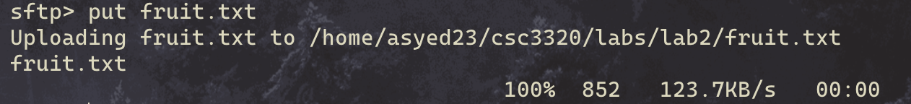

* 1. (5 points) After logging in to **snowball**, change your directory to **lab2** using relative address.

**Commands:**

cd /home/asyed23/csc3320/labs/lab2

* 1. (5 points) Use cat command to display the contents of the file.

**Commands:**

cat fruit.txt

* 1. (7 points) Copy the file to **lectures** directory and name it as **myfruit.txt** using the relative path.

**Commands:**

cp fruit.txt /home/asyed23/csc3320/lectures/myfruit.txt



* 1. (7 points) Go to your **lectures** directory using relative path. Use ls command to show that the newly copied and renamed file **myfruit.tx** exists.

**Commands:**

cd /home/asyed23/csc3320/lectures

ls



* 1. (5 points) Change your directory to **lab2** using absolute path.

**Commands:**

cd /home/asyed23/csc3320/labs/lab2

ls

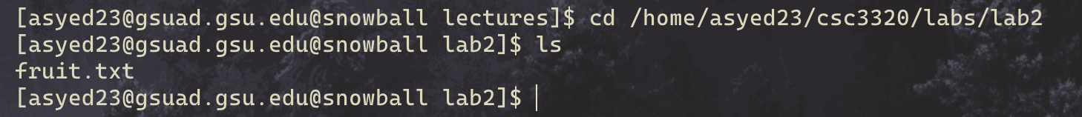

* 1. (7 points) Use cp command to move everything (recursively) of **lectures** directory under **lab2** directory.

**Commands:**

cp -r /home/asyed23/csc3320/lectures /home/asyed23/csc3320/labs/lab2

ls



* 1. (7 points) Issue a pwd and ls commands inside **lectures** directory (in its new location) and show **myfruits.txt**

exists in the correct path.

**Commands:**

pwd

ls

* 1. (7 points) Use ls command with appropriate flag to show the file permissions of the **myfruit.txt**.

**Commands:**

ls -l

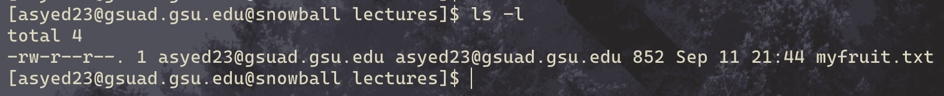

* 1. (10 points) Change the file’s permissions using a single command, so that user/owner can have rwx, groups and others can have --x permissions.

**Commands:**

chmod a+x myfruit.txt

* 1. (5 points) Remove **lectures** directory recursively (i.e, including everything within it).

**Commands:**

rm -r /home/asyed23/csc3320/labs/lab2/lectures

* 1. (10 points) Use history and other commands to store your latest 50 commands into a text file, called **last- name firstname Latest50.txt**.

**Commands:**

history | tail -n 50 > syedasrarLatest50.txt

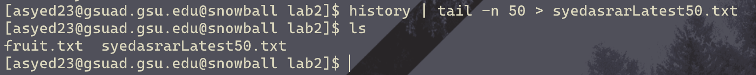

# Deliverables

For today’s lab, write a report by writing the commands to each question and sub-questions (as appropriate) and attaching the required screenshots (as output of each question/sub-question). Please name your report file as **last- name firstname lab02.doc (or pdf)**. You will need to submit your report file and the **lastname firstname Latest50.txt** file to the **Lab 02** dropbox in iCollege.

|  |  |  |  |
| --- | --- | --- | --- |
| Question: | 1 | 2 | Total |
| Points: | 20 | 80 | 100 |
| Bonus Points: | 0 | 0 | 0 |
| Score: |  |  |  |